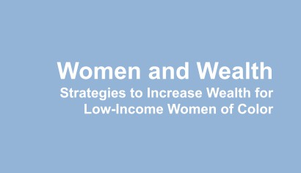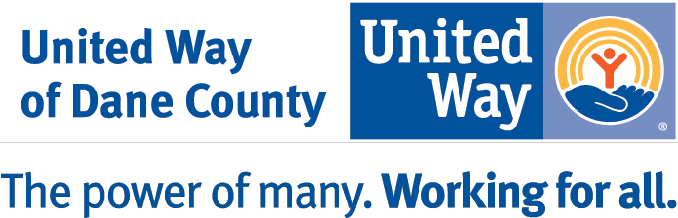

Title

1
United Way of Dane County ● 2059 Atwood Avenue ● PO Box 7548 ● Madison, WI 53707-7548 (608) 246-4350 ● www.unitedwaydanecounty.org

Why Investing in Wealth for Low-Income Women of Color is Important

Women, and particularly women of color, are significantly less likely to have access to wealth building opportunities.

Progress is Slow

According to the 2018 U.S. Census, 38.1 million Americans live below the poverty line, while a survey conducted by the American Payroll Association found that 74% of the population is living
paycheck-to-paycheck. People trapped in a cycle of generational poverty are focused on surviving
day-to-day, and not planning but tackling their current situation. In states that require ﬁnancial literacy training in high school, the average credit card debt is lower, and young adults have higher credit scores and lower loan default rates than those in states without the educational requirements.1

Income and assets (or wealth) together make up a family’s ﬁnancial security. Wealth—a household’s assets minus its debts—is a key measure of ﬁnancial well being because it acts as a cushion in times of emergencies such as unemployment or a health crisis. Wealth is also transferrable and allows households to ﬁnance subsequent generations’ futures by covering the costs of education, business investments or even a down payment on a home, allowing families to move up the economic ladder.

Average wealth has increased over the past 50 years, but it has not grown equally for all groups. In fact the gap today is wider than it has ever been. Research demonstrates that wealth is starkly divided along racial lines. Nationally, the typical Black household now possesses just 6% of the wealth owned by the typical White household, and the typical Latino household owns only 8% of the wealth held by the
typical White household.2 In 2016, the median wealth for Black and Hispanic families was $17,600 and
$20,700, respectively, compared with7 White families’ median wealth of $171,000.3 Disparate rates of
home ownership, return on the investment in a college education, and income inequality all contribute to this wealth gap.

Women of Color and The Wealth Gap

Women, and particularly women of color, are signiﬁcantly less likely to have access to wealth building opportunities. They are less likely to be eligible for employer-based health and retirement beneﬁts due to the nature of their employment or have access to tax incentives for savings and investment. Women are more likely to be caregivers for children or elderly parents, which impacts their careers and the ability to work and save. Finally, women are more likely to be carrying high levels of student debt, restricting the ability to build a nest egg for emergencies or to invest in homes or businesses.4

1 CISION Prweb, Financial Education Can Reduce Poverty and Help Americans Escape Its Cycle
Multi-generational poverty negatively affects every aspect of the American economy. Real Intelligence CEO Jeff Mount says ﬁnancial literacy education helps break the cycle of poverty. Karla Jo Helms Author July 6, 2020
2Demos, The Racial Wealth Gap: Why Policy Matters,
https://www.demos.org/research/racial-wealth-gap-why-policy-matters#footnote2_2m40khh
3 Center for American Progress, Systemic Inequalities; How America’s Structural Racism Helped Create the Black-White
Wealth Gap. Angela Hanks, Danyelle Solomon and Christian E. Well. February 21, 2018
4 https://womenswealthgap.org//women-and-wealth/

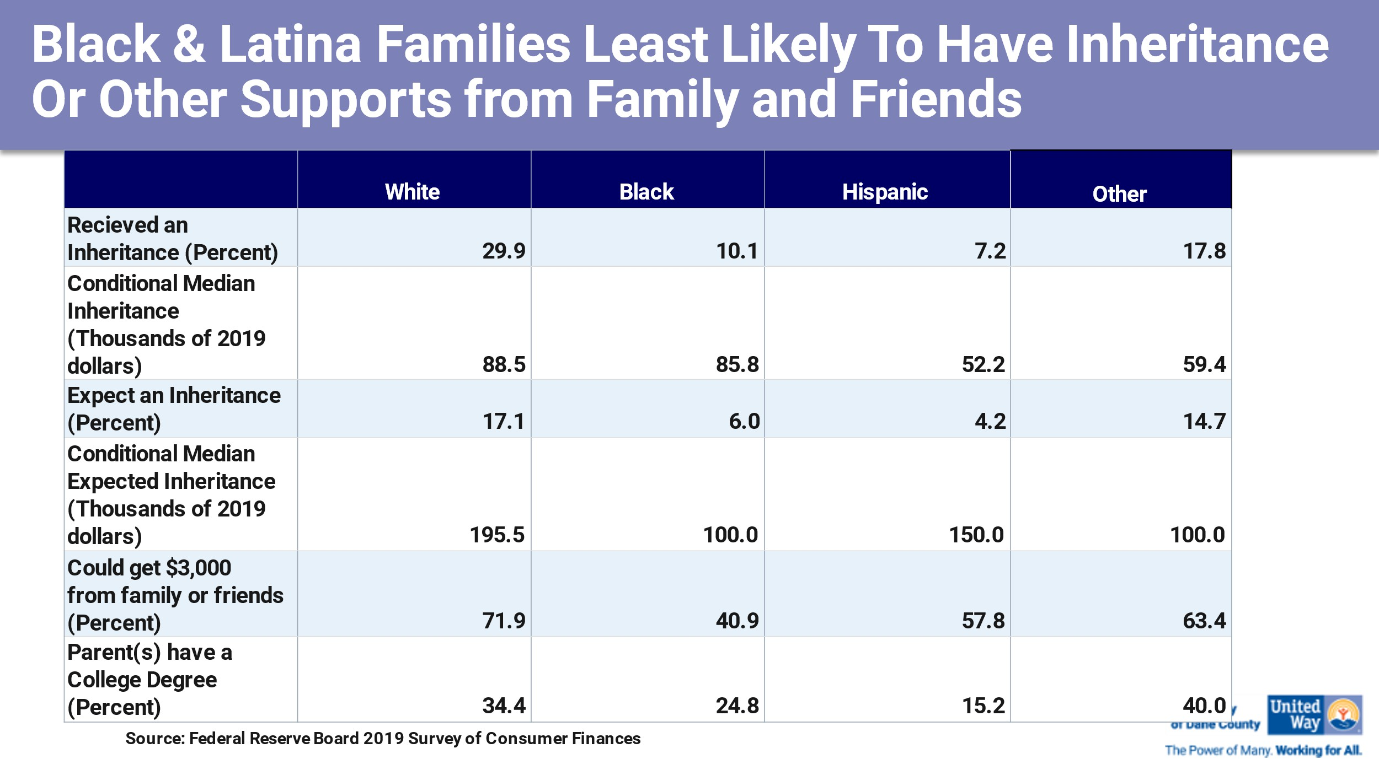Also contributing to the rising wealth inequality is income inequality. Over the past ﬁve decades, income inequality has sharply increased between the highest income earners and middle- and lower-income earners in the U.S.5 Adding insult to injury, the coronavirus pandemic made these inequities greater. Current stimulus packages are less likely to beneﬁt women of color as they are not as likely to own businesses and are less likely to work for employers with temporary paid leave policies.

In Dane County poverty is concentrated among women and children, especially for Black residents. Thirty-six percent of all Black women have incomes below the federal poverty limit and almost half (49%) of Black children are living in poverty.

A 2019 Center for American Progress report shared, “for centuries, American public policy systematically excluded Black households from opportunities to build wealth. The racial wealth gap was created and will only be eliminated by systematic and intentional public policy choices.”6

5 Robert Wood Johnson and Harvard TH Chan School of Public Health Life Experiences and Income Inequities in the United
States of America – January 2020
6 Center for American Progress, Simulating How Progressive Proposals Affect the Racial Wealth Gap
By Christian E. Weller, Connor Maxwell, and Danyelle Solomon August 7, 2019, 7:00 am

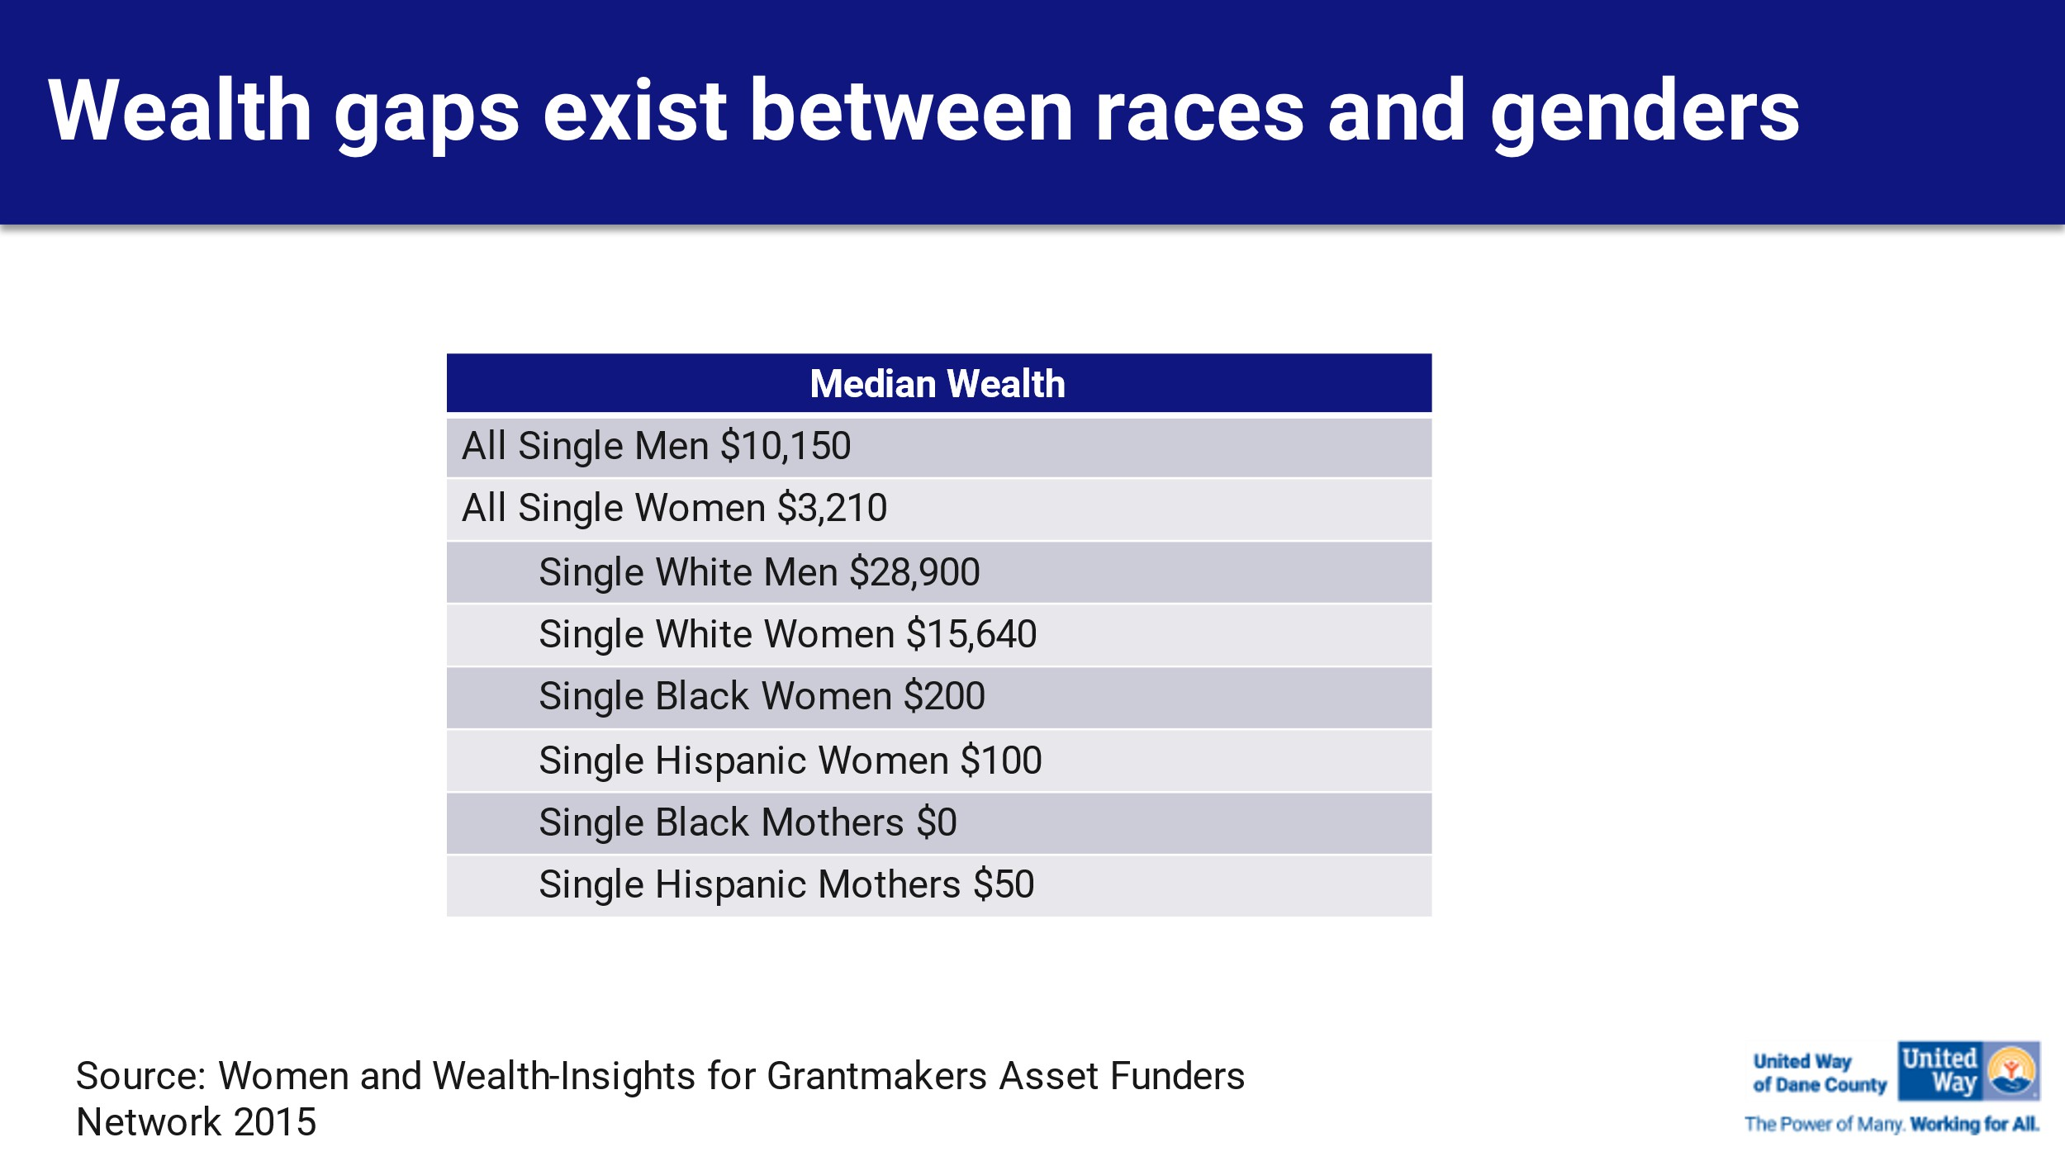

Disparities exist in rates of homeownership, wages and income, the number of Black, Indigenous People of Color (BIPOC) individuals who own their own businesses, access and participation in retirement security, usage of banks or credit unions, educational attainment for both kids and adults as well as the criminal justice system, and healthcare.

For most of these systems, these disparities are rooted in racism and a desire to keep certain people from doing well. For example, redlining and covenants have been systemic ways of keeping Blacks from owning homes in certain communities.

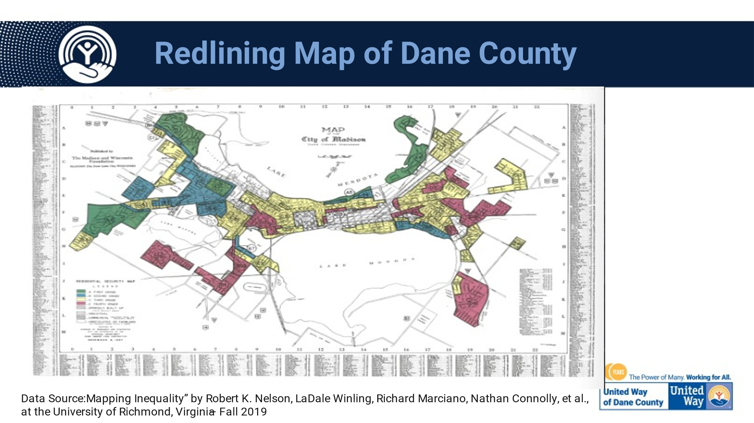
Other methods of systemic racism can best be represented in this picture provided by the
Asset Funders Network Advancing Equity: The Power and Promise of Advancing Credit 2022.

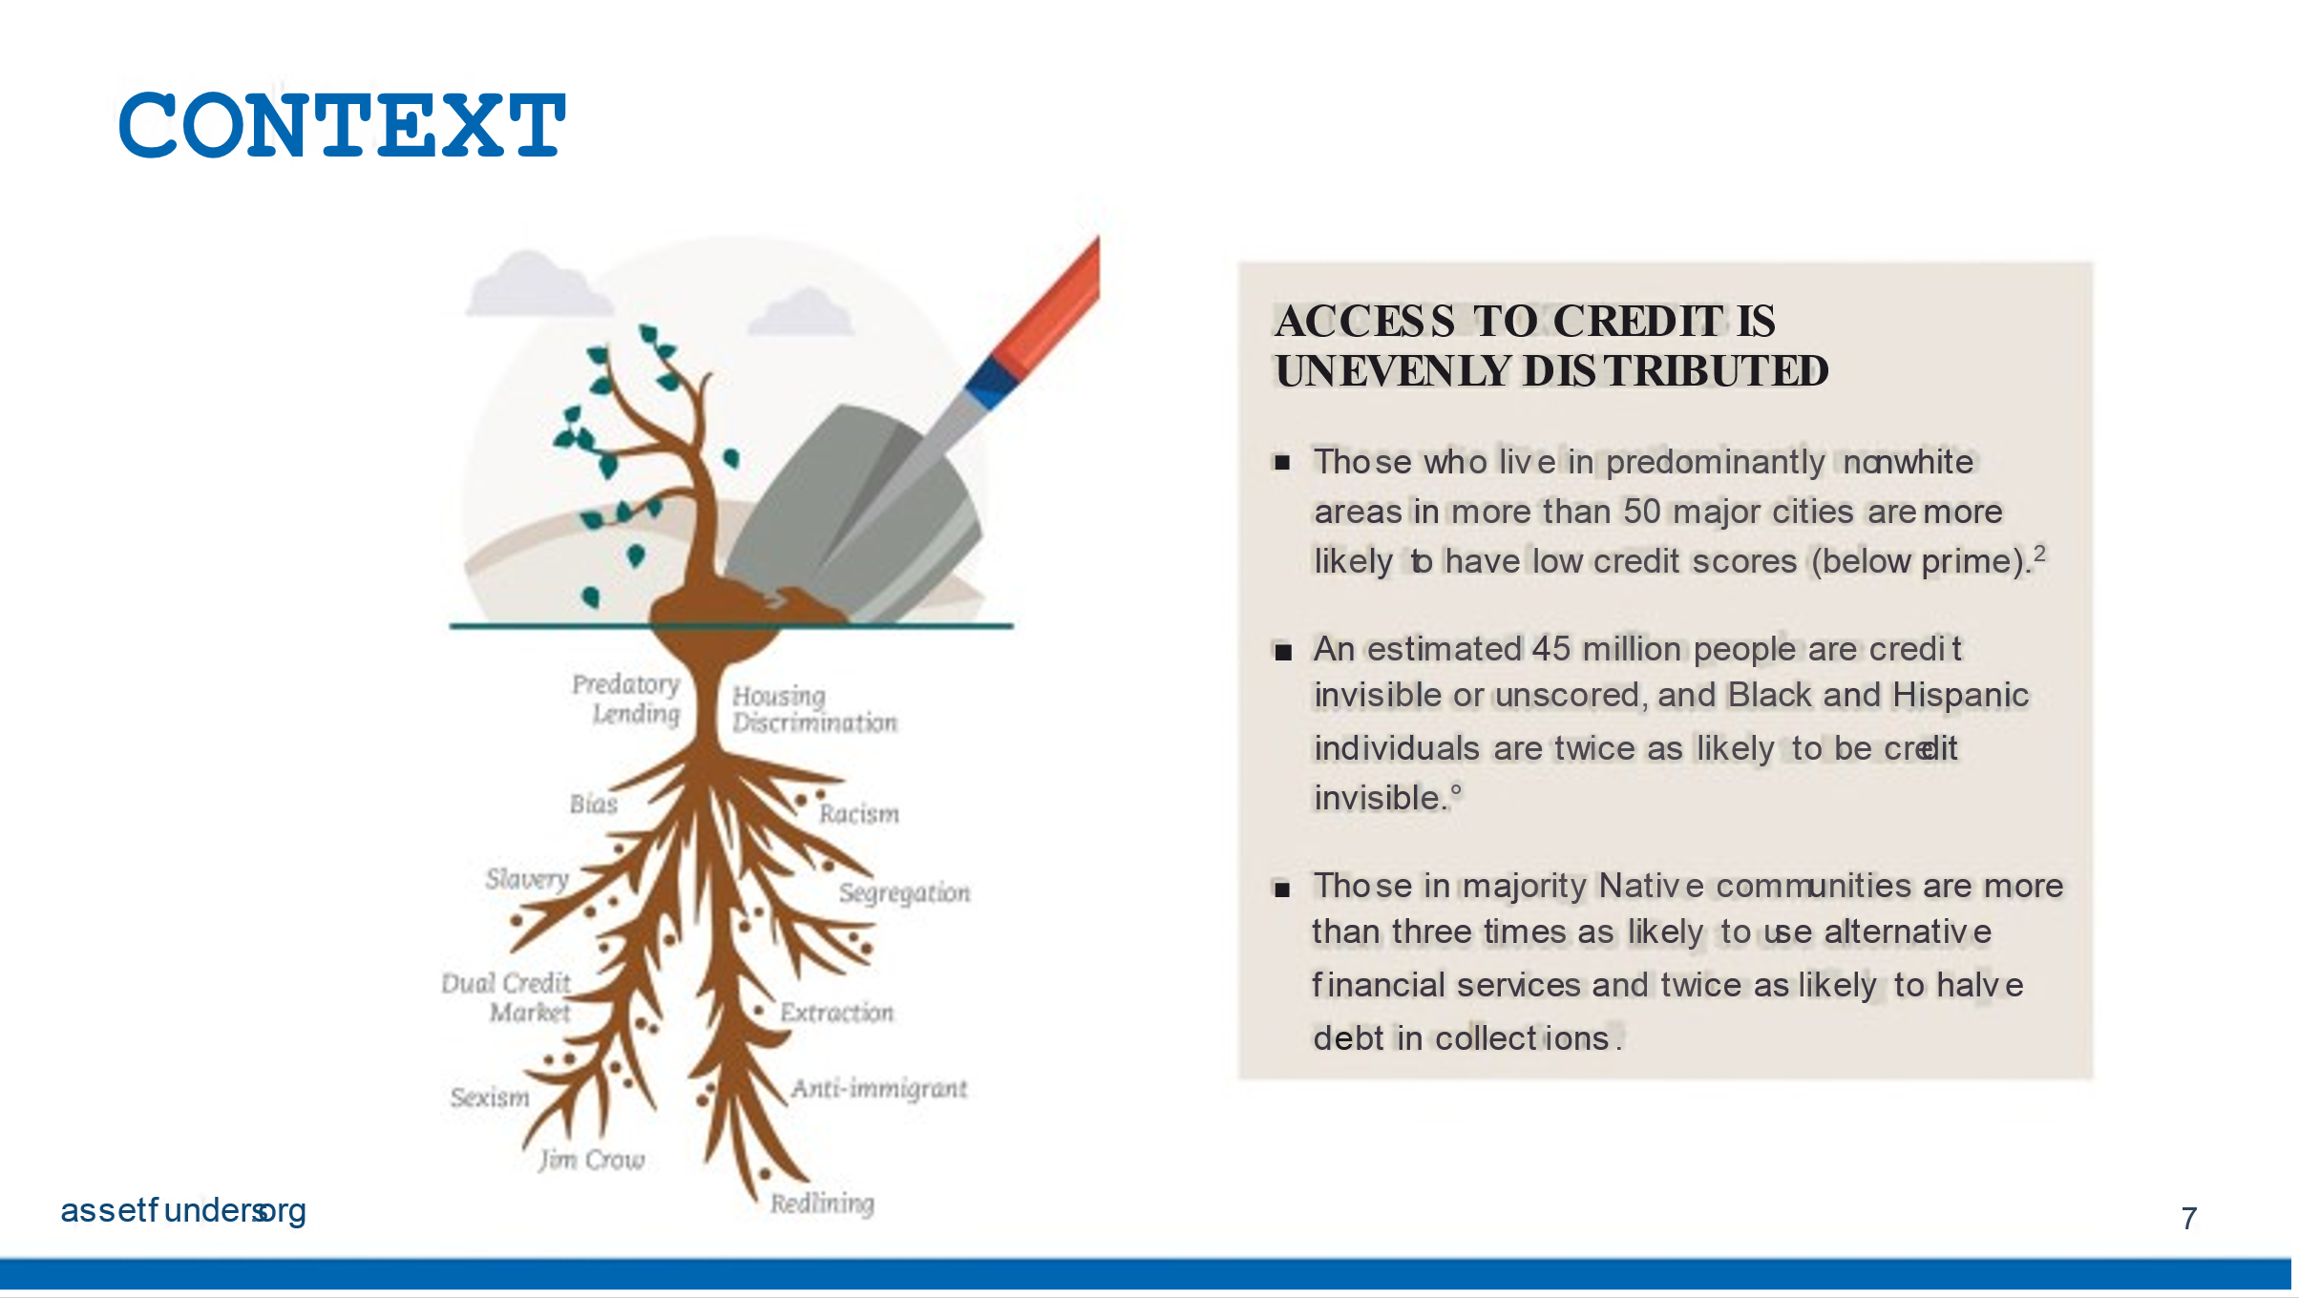

This report states, “People of color and immigrants work hard to build and sustain wealth. With a sense of optimism and a strong commitment to supporting their immediate families and leaving a legacy, people of color and immigrants have a long history of overcoming obstacles and achieving their ﬁnancial dreams. Black people are 4 times more likely than the general population to want to start their own businesses. Latinx millennials are 1.4 times more likely to support family members ﬁnancially while being more future-focused and more likely to be acting toward their ﬁnancial goals than
non-Latinx millennials.”7

It further states, “people of color have been blocked from realizing their high aspirations by structural racism and failures across multiple systems that have barred them from accessing and using credit and the intergenerational wealth-building opportunities access to credit makes possible. At the same time, ﬁnancial systems have disproportionately encumbered people of color with debt. For instance, people without visible and positive credit scores are far more likely to be denied a needed loan or cell phone plan, get charged higher rates to borrow money, and be rejected for a job or housing. The result is even further erosion of ﬁnancial stability and lower credit scores. As a consequence, these communities have been left behind in the drive to build economic security and wealth.”

To help overcome these systemic and racial barriers, the Women and Wealth Committee spent over nine months researching and determining what the best strategies would be for our community.

The Women and Wealth Committee focused our efforts on homeownership, entrepreneurial support and retirement security as the three priority strategies to increase wealth for low-income women of color with children in Dane County. Education and increasing understanding of credit is a tool to build wealth that overarches each of these strategies as access and knowledge to information is power.

7 This paper uses Black, Latinx, Indigenous, Asian & Paciﬁc Islander, and Southwest Asian/Middle Eastern/North African (SWANA/MENA) and immigrants to the United States to describe people who have experienced systemic racism and economic inclusion. Where research is cited, demographic terms will remain consistent with the original research. In some instances, the term “people of color” is used to also mean Black, Latinx, Indigenous, Asian & Paciﬁc Islander, and SWANA/ MENA people. SWANA is the decolonized naming for the region of Southwest Asian/North African. However, as there may be less familiarity with this term, the paper uses SWANA/MENA.

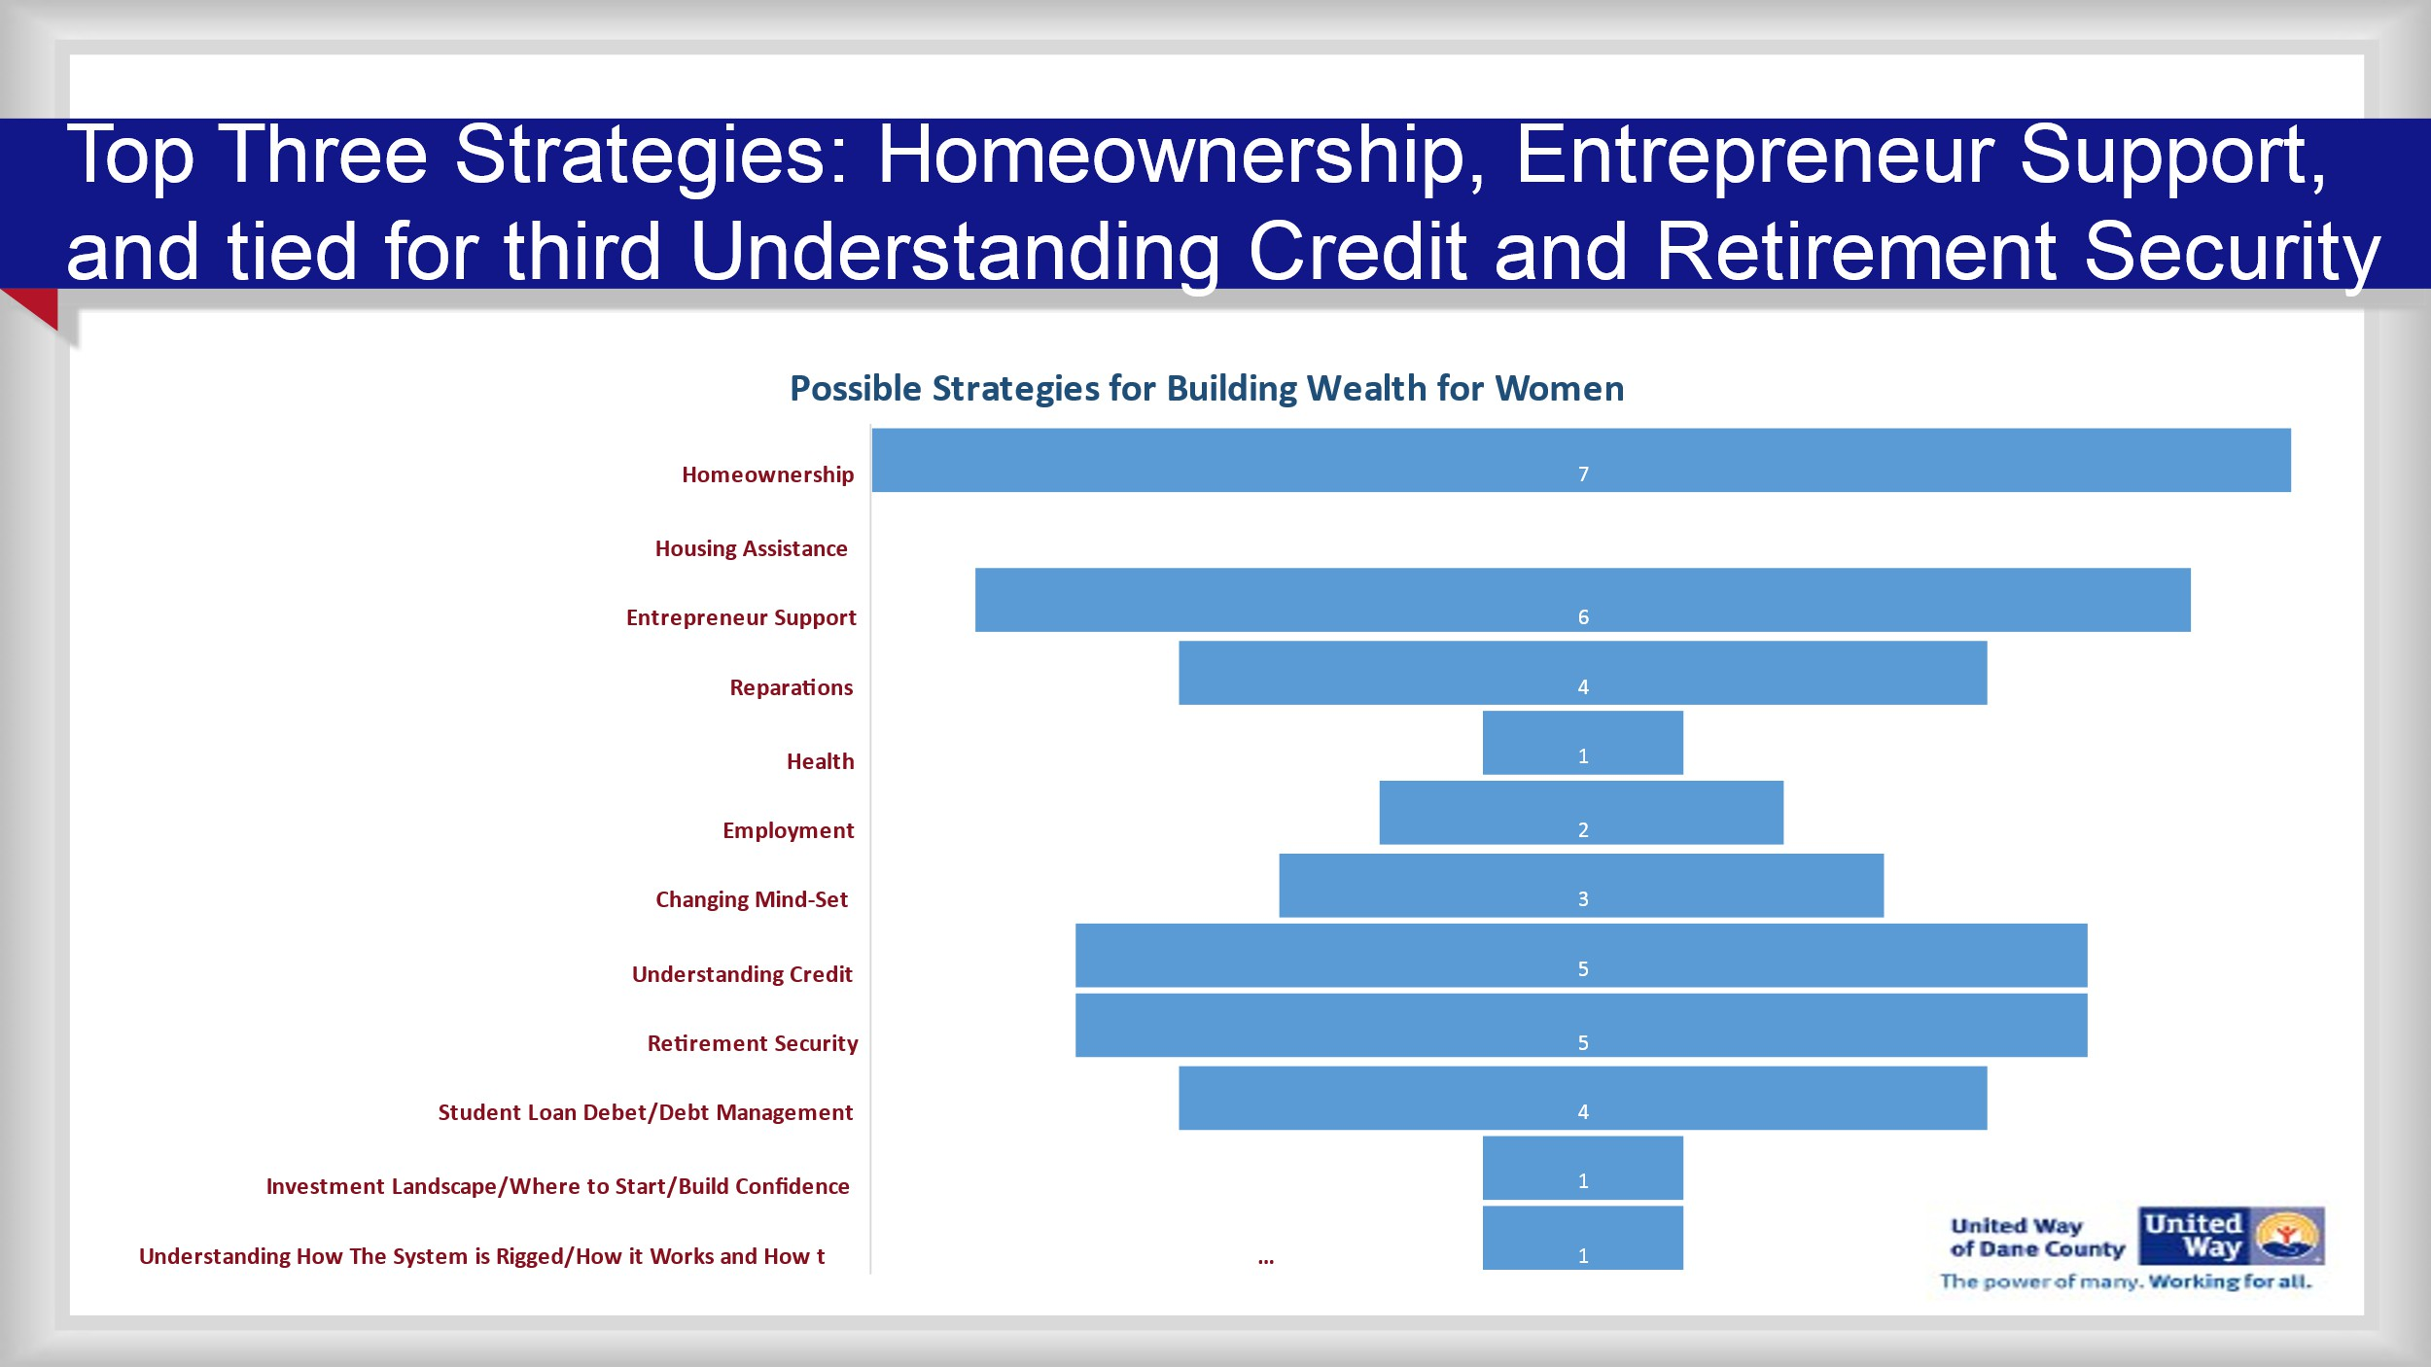

The strategies align with the work of the Income Community Solutions Team (CST) goal of moving more people on pathways out of poverty, to decrease family homelessness and move people toward economic stability.

The Women and Wealth strategies speciﬁcally align with the following Income portfolio goals:
● Increase the number of families in permanent housing (home ownership).
● Increase the number of individuals who gain family sustaining employment (entrepreneurial support).
● Increase the number of individuals who receive education services to gain family sustaining
employment (retirement security and understanding credit for more than just employment but for all three women and wealth strategies).

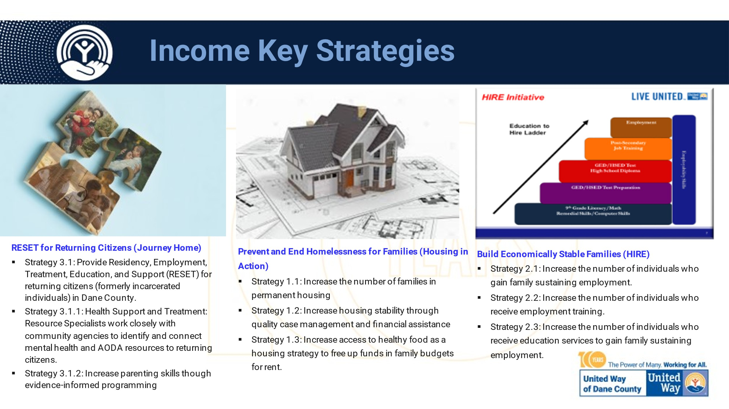
The chart above shows the strategies within the Income CST portfolio. It is important to note that the Housing Delegation is currently looking at our housing strategies to determine how United Way can do more in terms of prevention for families who are at risk, and get upstream to help move women who want to own a home into home ownership.

Now for a more in depth look at each strategy:

Homeownership

A Capital Times article dated March 4, 2022, entitled “Black Home Ownership Rate is One-Third of the
U. S. rate,” reports that just 15% of Blacks in Madison own their own homes:

“Researchers used U.S. Census data from 2019 — the most recent year available — to calculate homeownership rates for the state’s ﬁve most populous cities: Milwaukee, Madison, Green Bay, Kenosha, and Racine, as well as for the state as a whole. They compared rates for White residents with rates for Black and Hispanic residents, who make up the state’s two largest minority groups and face the largest disparities in homeownership. About three-quarters of Black Wisconsinites and 44% of Hispanic Wisconsinites live in one of those cities.

Of those ﬁve cities, only Green Bay has a lower Black homeownership rate than Madison, coming in at just under 6%, compared to just over 15% for Madison. Statewide, just over 25% of Black Wisconsinites own their homes, compared with 72% of White Wisconsinites. For Hispanic residents, Madison’s homeownership rate is the lowest of the ﬁve cities at just 30%, compared
to about 41% statewide. In each of the cities, Hispanic residents are more likely to own homes than Black residents are, but less likely than White residents are.”

The Washington Post reported that most American renters — 72% — say they want to buy a home at some point in the future instead of continuing to rent, according to the Pew Research Center.8 But many Black Americans have been left out. Black Americans struggle with a deep wealth gap. In fact, recent research shows that only 44% of Black Americans own a home compared to 74% of White Americans. Homeownership is important for accumulating and passing on wealth, which means the trailing homeownership rate further impacts Black Americans’ ability to build generational wealth over time.
https://www.washingtonpost.com/business/2022/04/26/black-share-homeownership-dispropor tionate
ly-low/

Another Washington Post Article states that the persistent gap between the percentage of homeowners who are White and those who are Black continues even though homeownership rates in general
climbed to 65.5% in 2020, a 1.3-point rise from a year earlier, according to the
National Association of
Realtors. While Black homeownership rates increased to 43.3%, they still lag behind those of White
Americans (72.1%), Asian Americans (61.7%) and Hispanic Americans (51.1%).

8 https://www.pewresearch.org/fact-tank/2017/07/19/more-u-s-households-are-renting-than-at-any-point-in-50-years/

Our Home Ownership Strategy

Homeownership

1. Provide or increase access to homeownership training/preparation to ensure people understand what the expectations are for homeownership.
2. Create a funded, sustainable program that provides down payment assistance for housing purchase.
3. Provide or expand access to ﬁnancial education programs that help prepare individuals for mortgage costs and on-going household expenses.

It is important to note here that we are not trying to reinvent the wheel but instead enhance what is currently existing in our community, while addressing the concerns and barriers that have been identiﬁed by the Women and Wealth Committee as priorities to focus on (due to gaps or a lack of services or eligibility).

Barrier/Gap Identiﬁed | Proposed Strategy to Address
Individuals have participated in other home ownership programs, completed them, and then found out that they are not qualiﬁed for ﬁnancial assistance. | ● Provide screening in the beginning of a  course or assistance program and set agreed upon expectations so that participants are clear on what assistance is available before committing time or resources to the program.  ● Within this expectation setting, there is a  timeline identiﬁed and agreed upon by all parties for the type of assistance that will be provided.This may take some time, so we want to assure that everyone is on the same page and terms are agreed upon in writing.  ● Use/create a pre-screening tool to outline  everything in terminology that is understood by the participant.

 | ● | Create a United Way of Dane County Home Ownership program for a speciﬁc population where there is currently a gap and a need: low-income women of color who have children.
Participants were unclear of how long it would | ● | Pre-screening tool will include a checklist of
take to be “ready” for home ownership. | ● | all the steps needed to be deemed “ready” for  home ownership.  Realistic timelines for completion will be included for every item on the checklist. This checklist must be signed by the participant.
Participants do not want to wait years to own | ● | Participants will own their home as of the
their own home. |  | date of their closing.
Participants do not want to wait for a house to be | ● | We will partner with more than one program
built. |  | to meet the needs of families in a more  expedited fashion.
Participants felt like they were being talked down | ● | We will make sure that cultural competency
to during trainings. |  | and good customer service is provided  throughout the pre-home ownership training.
Participants have money for a down payment but | ● | We will work with each participant on what
need help with closing costs. |  | their speciﬁc monetary needs are.
Participants are unsure about whether they are | ● | We understand that it might take some time
eligible / length of time to acquire home |  | for people to be ready for home ownership.
ownership. |  | We will be there to help participants through  each step towards that home ownership.

Key Home Ownership Program Considerations
We will work with each woman to help determine what they are looking for in a home for their family. We will limit the amount of funding available to each family to ensure we can assist as many families
as possible. The maximum amount available to each woman will be up to $15,000. This would be in alignment to what the City of Madison will now be offering. However, we do know that restrictive support is not helpful, so we will work with partner agencies to ensure that the 10% down payment cost can be reached for each family as we continue to build out this strategy. Also, we will need to take into consideration housing costs in our community.

Financial education is critical for the women in this program to be successful. So, it is important that
we have a strong ﬁnancial education partner. Several of the women that participated in the Women and Wealth Committee are prospects for ﬁnancial education partnerships as they currently offer culturally competent programming that would meet the needs of clients. We will create a program with a couple of options available for women to decide who they would like to work with.

Loan and lending information will be provided. Applying for a loan can be daunting and knowing who the best lender for your needs is important. We want to make sure that we understand what each ﬁnancial institution has to offer women in this program and make this process as uncomplicated as possible. If they have applied for home loans previously, we will seek to help them understand why they were denied and help them improve their prospects for next time.

We are exploring several partnership options, including partnering with existing housing programs within the Income CST portfolio to pilot this offering to the women in these programs, as we know that many of them move from our housing program into home ownership. Because our dollars are from our donors and not the government, we are in a unique position to provide this home ownership strategy to this population, as other programs cannot be selective in who they support. With our unique partnership opportunity and donor funds, we can help move more women into home ownership to beneﬁt them and their children.

Entrepreneurial Support

Another unique opportunity is the entrepreneurial support for women-owned businesses. Owning a business is one of the best strategies to build lasting wealth. Many Black Americans have used business as a key strategy to build personal wealth and develop the Black community. However, Black entrepreneurs face challenges both in starting and growing their businesses. They face numerous structural impediments such as unequal access to ﬁnancial capital and discriminatory practices in procuring private and public contracts9.

There are now more than 4 million minority-owned companies in the U.S., with sales totaling close to
$700 billion, according to data from the Senate Committee on Small Business and Entrepreneurship. And over the last 10 years, minority businesses accounted for more than 50% of the 2 million new businesses in the nation and created 4.7 million jobs. But access to ﬁnancial support is still an issue for minorities nationally — they make up 32% of the U.S. population, but only 18% own a business. By comparison, around 71% of U.S. businesses are White-owned, according to data from the Small Business Administration, and in Wisconsin, racial minorities owned only 6.8% of businesses in 2021.
By comparison, people of color make up 11.2% of the state’s workforce.

According to the US Census for Dane County 2017, there are 1,855 women-owned ﬁrms and 522 minority-owned companies.

Both Brava Magazine https://bravamagazine.com/suppor t-black-owned-businesses/ and the Madison Chamber of Commerce https://www.madisonblackchamber.com/director y provide lists of the Black-run businesses in our community.

Without adequate support, Black business owners struggle both to open businesses and keep them open. In a recent article from Channel 3000, one local business owner shares his struggle to remain open:
https://www.channel3000.com/am-i-going-to-be-next-madisons-black-business-owners-worr y-about-th
eir-futures-as-more-restaurants-stores-close/

9 ABFE Wealth and Asset Building Black Facts

Our Entrepreneurial Support Strategy

Below are key components of a recommended support program for entrepreneurs in Dane County, as identiﬁed by the Women and Wealth Committee:

1. Provide entrepreneurial support through mentoring.
2. Provide ﬁnancial support/start-up and administrative support.
3. Determine how we can provide group insurance to decrease costs for entrepreneurs.
4. Provide child care assistance.
5. Provide microloans for emergencies.
6. Provide safe space for sharing ideas.
7. Provide professional training conferences for on-going support and learning opportunities.

Mentoring

For the entrepreneurial support strategy, many women expressed that support currently being provided by other programs is for a brief period of time (2 years or less). We will provide support for a longer period of time as identiﬁed by each woman that we are serving through this program.

A program model that this committee recommends following is the Circle of Support model of mentoring that JustDane provides for individuals who are returning to the community from prison. This committee recommends implementing a similar model for entrepreneurial support. Most important is that the program provides mentors who look like the women that they are mentoring. Several of the women participating in other programs expressed that they felt “talked down to” by women who did not look like them or could not relate to their struggles. Also important to this success is having each mentor participate in training before they mentor. We will rely on each potential business owner identifying the areas that they would like to work on ﬁrst, and together with their mentor, continue to build and identify other areas of focus.

Financial Support/Start-up and Administrative Support

Members of the Women and Wealth Committee explored different ways to provide support, and the need to help provide start-up ﬁnancial support and administrative support rose to the top as priority program components to address current gaps in Dane County. Start-up assistance could be offered in several ways, including:
o Grants
o Interest free/low interest loans (will need to be repaid within a speciﬁed amount of time that has been speciﬁed in the contract/MOU),
o Access to ongoing support by becoming a partner agency or donor designation agency if program aligns with one of United Way of Dane County’s Agenda for Change areas
o Help with crowdfunding opportunities

Several years ago, United Way offered grant writing workshops to partner agency staff. We will explore a partnership with a local partner to provide low- or no-cost grant writing trainings. We would also like to explore the opportunity to have some shared administrative support in a shared services model.

Group Insurance

Insurance is expensive. It is practically cost prohibitive for small start-up companies/agencies to consider purchasing insurance for their business. We would like to explore group insurance options for low-income women starting up their business. We would seek a program similar to the one that is currently available for the businesses in the American Family Insurance Spark Building in downtown Madison. We will also explore the possibility of partnering with them on this option.

Child Care Assistance

United Way of Dane County has learned the importance of offering childcare assistance with the HIRE Initiative, our workforce training program. Repeatedly, this barrier came up in conversation as we explored how to support women as they start their businesses. We would like to replicate a similar model for this population.

Micro-Loans

Microloans may be used to provide emergency loans for car repairs, equipment purchase, software upgrades, technology upgrades, etc. These loans would need to be repaid within a 12-month timeframe and the maximum amount of the loan would be $1,000.

Space

The need for a “safe space for conversations” came up as key to supporting entrepreneurs. Several women spoke about ideas they had that were stolen when they were discussed in other start-up programs in our community. We will partner with local providers to ﬁnd or create/facilitate a space where women can learn from one another, seek input on their ideas, and not have to worry about someone stealing their ideas for their own. We have had offers from several of the women who were on the committee to have their oﬃces used as “safe spaces” for women.

Training & Conferences

We would like to create a forum for best-practice sharing, training, and education. Similar to ongoing trainings that businesses offer, we would like the same type of offerings but focused on Black and Latina women. Training topics can range from branding, ﬁnancing, trauma, leadership, and mentoring, as well as how to connect to a mentor and still maintain one’s identity/self-worth. In addition to the ongoing personal trainings, the Committee suggests providing authentic opportunities to network with other women with similar experiences, backgrounds and that look like them; where again they feel safe in sharing where they are struggling without being judged, talked down to or have their ideas stolen.

With all these strategies, we want to empower women to take charge of their destinies and be supported in the ways they want, and for as long as they need the support. We are conﬁdent that these supports will help women secure a better future for themselves and their families.

Retirement Security

One of the most challenging strategies to approach is retirement security. Retirement security is a personal issue. Discussing retirement security often calls into question decisions a woman has made throughout her life. The last thing we want to do is make people feel bad about past choices and decisions. As such, this strategy will focus on providing advocacy and education for young girls so they can make informed decisions over their lifetime. Here is where the idea that “knowledge is power” is
key to success. We recognize that you cannot wait to start thinking about these issues ten to ﬁfteen years before you retire; instead, you need to start planning as soon as possible.

Our Retirement Security Strategy

As discussed in the homeownership and entrepreneurial support strategies, “you don’t know what you don’t know.” Providing early education and awareness is key. The committee recommends developing a tool, such as an app for mobile devices, that would provide information and tools to empower women
to take control of their retirement security. If participants have a retirement plan that they can access through their employer, we will encourage them to do so, but also make them aware of the state retirement plan if that is applicable to them.

Below are the key program recommendations that the Women and Wealth Committee identiﬁed for retirement security:

1. Create or support programs that provide early education/awareness on planning for retirement.
2. Design a retirement tool speciﬁcally for entrepreneurs to help make sure they are prepared for retirement.
3. Help participants learn more about the state retirement program.

Early Education/Awareness on Planning for Retirement

We know the earlier in life we can engage women of color with this strategy, the better. We are looking at a ﬁnancial literacy program speciﬁcally focused on retirement plans for high school-aged students who are entering the workforce. This is a great opportunity to use social media platforms to engage these young women in planning for their future. For example, making sure they understand that if they are planning on having a family that this will impact their social security beneﬁts. The longer they are out of the workforce, the lower the amount of social security beneﬁts they will have available for retirement. If their employers offer a retirement plan, we would advise them to take advantage of that opportunity early in their career. Those with dreams of entrepreneurship will want to make sure they are putting money away for their retirement. We want to equip them to make the best decisions for themselves and their families.

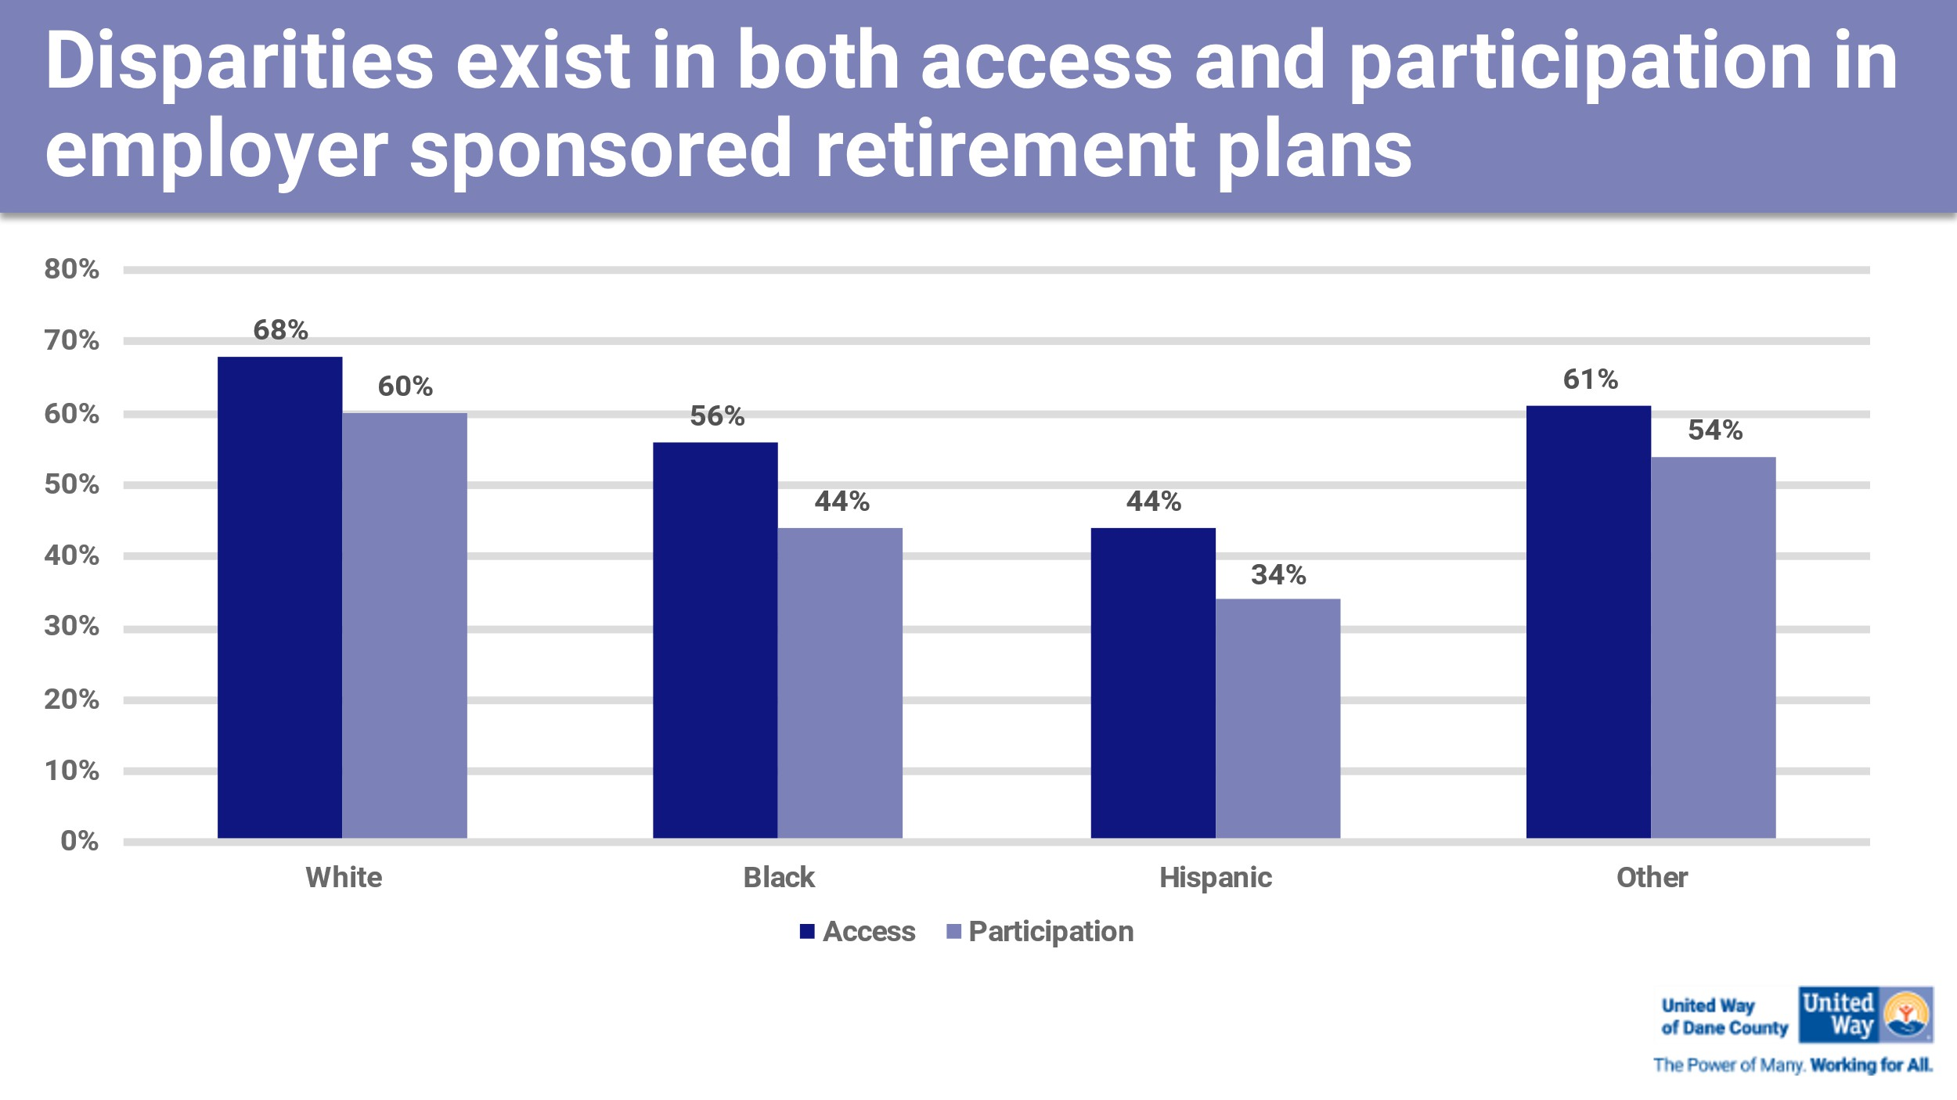

Design a Retirement Tool

For this strategy, we would seek additions to current retirement tools as a component just for entrepreneurs. Depending on the size of their business, entrepreneurs may not be able to offer a retirement plan for themselves or their employees. Being able to plan early and know what is needed to ensure their ﬁnancial retirement future will be important for this population. There is some mistrust of ﬁnancial institutions and ﬁnancial planners that is historical from how people of color have been treated by these institutions, so alternatives will need to be offered.

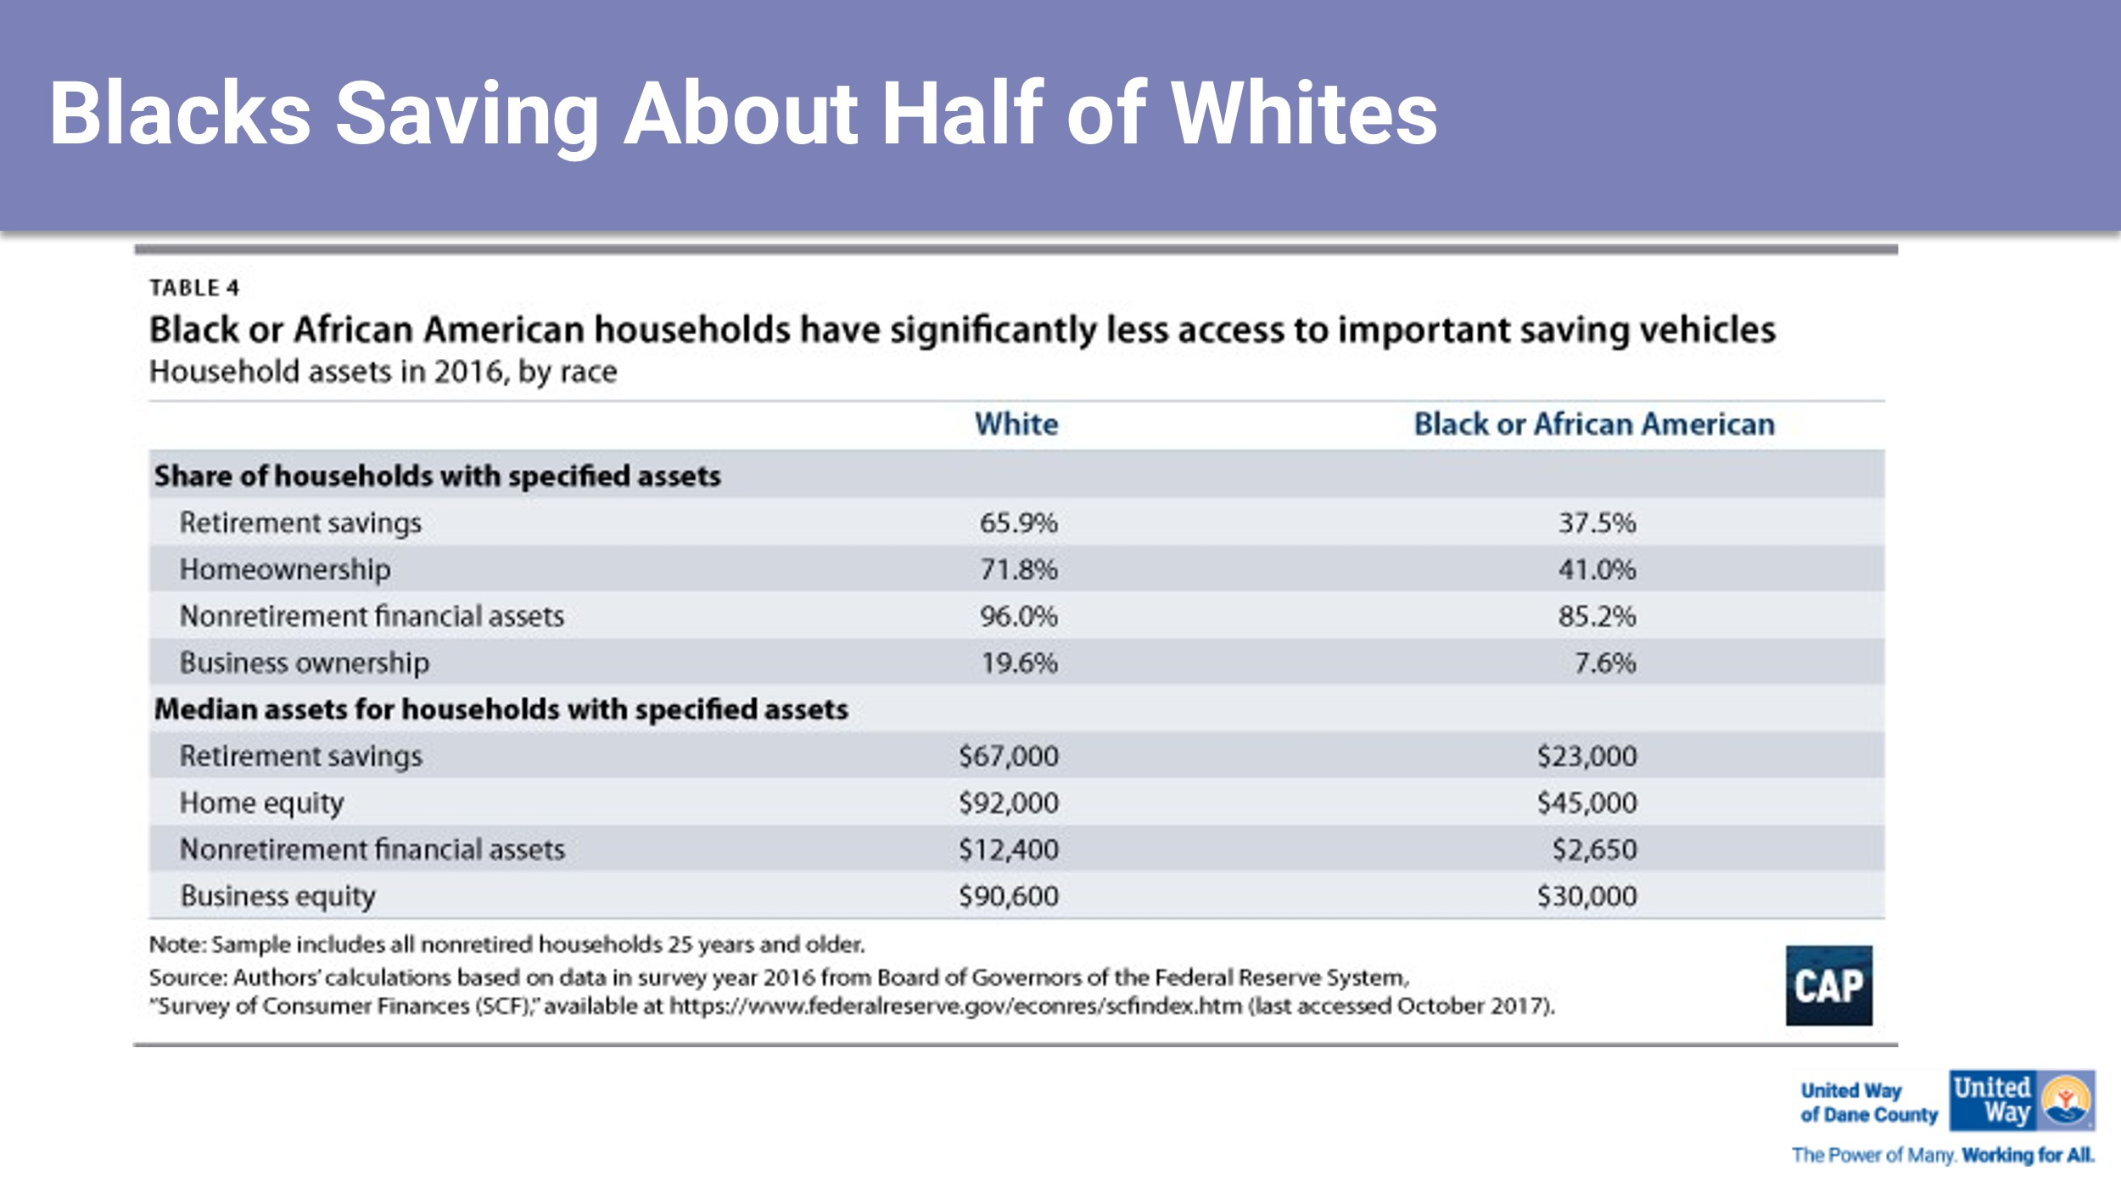

Our interest in all these strategies is to impact the disparities outlined in the chart above. We want to see the amount of savings, retirement dollars, business equity and home equity increase for women of color so they too can pass down wealth to their children.

We are excited to see these strategies begin and change the lives of those who are participating.

List of Volunteers

Alexzandra Shade
Chair
Director, Social Corporate Responsibility
CUNA Mutual Group

Suzanne Johnson
Vice Chair
Vice President Branch Banking
Park Bank

Sara Alverado Committee Member Executive Director
Alverado Real Estate Group

Kathy Blumenfeld Committee Member Secretary - Designee
Wisconsin Department of Administration

Fatu Caesey Committee Member Executive Director Carisu Home Care

Andreal Davis Committee Member Executive Director
Cultural Practices That Are Relevant

Norma Gallegos
Committee Member
Workforce and Careers Pathways Manager
Centro Hispano

Brenda Gonzales Committee Member Community Relationship
University of Wisconsin Madison

Uchenna Jones Committee Member Registered Nurse
SSM St. Mary’s Hospital
Sagashus Levingston Committee Member Founder and CEO Infamous Mothers Jillian Stacey Committee Member
Community Volunteer Leader

Grace Trewartha Committee Member Founder and CEO
Live Beneath Your Means

Angela Jones
United Way of Dane County Staff
Director, Income

